Principles of Management

CHAPTER TWO

Managerial Decision Making

LEARNING OUTCOMES

  - What are the basic characteristics of managerial decision-making?
Managers are constantly making decisions, and those decisions often have significant impacts and implications for both the organization and its stakeholders. Managerial decision-making is often characterized by complexity, incomplete information, and time constraints, and there is rarely one right answer. Sometimes there are multiple good options (or multiple bad options), and the manager must try to decide which will generate the most positive outcomes (or the fewest negative outcomes).

- Decision-making is the action or process of thinking through possible options and selecting one.
  - Notice this a process. In other words, we can break this procedure down into individual parts to better understand how to make a decision.
  - Normally stakeholders have completing needs, priorities, and values. Part of a manger's job - as we saw last chapters - is to balance and prioritize these requests. Stakeholder analysis is a process we will learn about in future chapters.
  - What are some negative outcomes of poor decision making?

- Deciding When to Decide
  - Managers frequently make decisions without complete information.
  - In this regard, what ability must an effective manager develop?

- What’s the correct answer?
  - Does every managerial decision have a single correct answer?

  - Does every managerial decision have a single incorrect answer?

- What’s the most ethical answer?
  - How can a manager consider ethics in decision making?

  - Maximizing shareholder wealth has come under scrutiny lately, especially when this objective is at odds with other stakeholders or ethical practice. Do you think the main objective of management is to increase value for shareholders? Why or why not?

2.2. What are the two systems of decision-making in the brain?

- The brain processes information to make decisions using one of two systems: either the logical, rational (reflective) system or the quick, reactive system.

  - Would it be better if you used the reflective or reactive system? Which do you tend to use - and with what result?

- “The quick route is not always the best decision-making path to take…”

  - Have you ever made a quick decision that ended badly?

- The role of emotions:
  - Emotional intelligence is the ability to recognize, understand, pay attention to, and manage one’s own emotions and the emotions of others.
  - It involves self-awareness and self-regulation—essentially, this is a toggling back and forth between emotions and logic.

  - Describe each of the following elements of emotional intelligence:

    - Self-awareness

    - Self-regulation

    - Empathy

    - Social skills

2.3. What is the difference between programmed and nonprogrammed decisions?
- Programmed decisions are those that are based on criteria that are well understood, while nonprogrammed decisions are novel and lack clear guidelines for reaching a solution.
  - Managers can establish rules and guidelines for programmed decisions based on known fact, which enables them to reach decisions quickly.
  - Give an example of a programmed decision that a manager might face.

- Nonprogrammed decisions require more time to resolve; the decision maker may need to conduct research, collect additional information, gather opinions and ideas from other people, and so on.
  - In other words, we can't just write a policy handbook to solve these problems. We need managers to use judgement in these cases. There's less "if this, then that" decision-making and substantially more ambiguity.
  - Give an example of a nonprogrammed decision.

- The decision making process
- Recognize that a decision needs to be made.
- Generate multiple alternatives.
- Analyze the alternatives.
- Select an alternative.
- Implement the selected alternative.
- Evaluate its effectiveness.

What do you perceive to be the most overlooked steps in the process?

2.4 What barriers exist that make effective decision-making difficult?
There are numerous barriers to effective decision-making. Managers are limited in their ability to collect comprehensive information, and they are limited in their ability to cognitively process all the information that is available. Managers cannot always know all the possible outcomes of all the possible options, and they often face time constraints that limit their ability to collect all the information that they would like to have. In addition, managers, like all humans, have biases that influence their decision-making, and that can make it difficult for them to make good decisions.
- We learn about decision-making barriers so we can address them in the decision-making process. Can you describe the relationship between these barriers and the decision-making process?

- What is the definition of bounded rationality?

- Try to think of examples in your own life that fit within the scope of this idea. Going through this mental exercise helps the definition stick for a quiz, test, or homework assignment.

- What is the definition of escalation of commitment?

- Explain the concept of confirmation bias.

- How does process conflict differ from relationship conflict?

2.5 How can a manager improve the quality of her individual decision-making?
Managers tend to get better at decision-making with time and experience, which helps them build expertise. Heuristics and satisficing can also be useful techniques for making programmed decisions quickly. For nonprogrammed decisions, a manager can improve the quality of her decision-making by utilizing a variety of other techniques. Managers should also be careful to not skip steps in the decision-making process, to involve others in the process at various points, and to be creative in generating alternatives. They should also engage in evidence-based decision-making: doing research and collecting data and information on which to base the decision. Effective managers also think critically about the quality of the evidence that they collect, and they carefully consider long-term outcomes and ethical implications prior to making a decision.

- Experience: It is commonly said that your degree will get your first job, but experience will get you the second. Why is experience so important?

- How does satisficing differ from sacrificing?

Techniques for Making Better Nonprogrammed Decisions
- Recognize that a decision needs to be made.
- Generate multiple alternatives.
- Analyze the alternatives.
- Select an alternative.
- Implement the selected alternative.
- Evaluate its effectiveness.

- What are two effective strategies for generating multiple alternatives?

- Ethical decision making
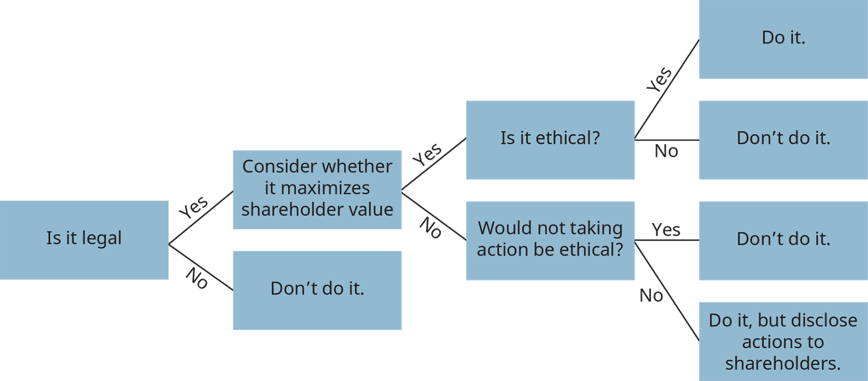

  - According to James Rest, what are the four components to ethical decision making?

2.6. What are the advantages and disadvantages of group decision-making, and how can a manager improve the quality of group decision-making?
Groups can make better decisions than individuals because group members can contribute more knowledge and a diversity of perspectives. Groups will tend to generate more options as well, which can lead to better solutions. Also, having people involved in making decisions that will affect them can improve their attitudes about the decision that is made. However, groups sometimes fail to generate added value in the decision-making process as a result of groupthink, conflict, or suppression of dissent.

- List two benefits and two challenges related to group decision making.

- Compare and contrast brainstorming and groupthink.

- What are the key elements to the composition of a successful group for decision making?

This file is copyright 2019, Rice University. All Rights Reserved.

